Chemistry Showcase Talk- Abstract submission
A booklet will be created for the upcoming Chemistry Showcase. As part of this, you will need to submit an abstract of your talk. The abstract deadline is Monday 25th August 2025.

Please submit using this link: https://e.pcloud.com/#page=puplink&code=3zLZRPzBia1bmypxni4N97ofPBqHrD2y

Title, authors and affiliation(s) should be written in the style used below. Please follow the punctuation and name order exactly. Please include references (RSC Standard referencing) and/or acknowledgments at the end of the abstract.

Presentation Title
Presenting author surname, first name • email address.
Presenter Surname, First name¹, collaborator or co-author surname, first name², etc
¹ University of Cambridge, Department of Chemistry.
² Affiliation, department, institute, etc
Main body of text
(should not exceed 300 words.)

References
1. (insert single tab) Reference text.
2. (insert single tab) Reference text, etc.

Please delete any text that is not relevant to your submission.
Please note that the booklet entry will not look exactly like your submission, but like the example below.
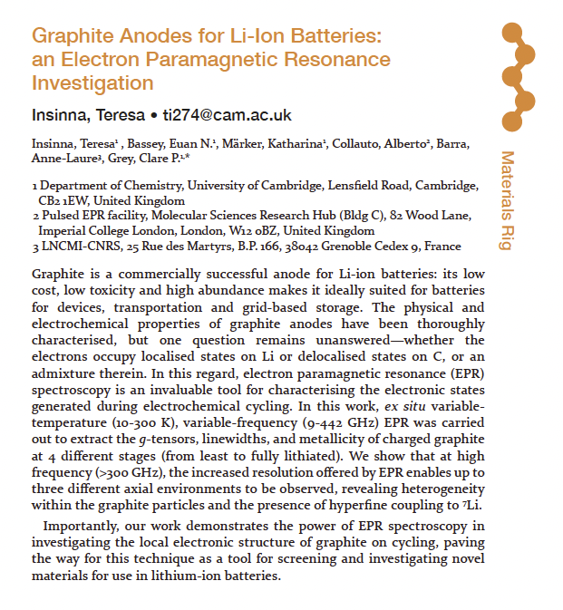

Please submit your abstract in this ‘.doc’ format.
The finished file should be named <LAST NAME, INITIALS, RIG, SCPRES25>

*** Images may be used but must be submitted separately in order that we can format the booklet correctly. Please upload images in format <LAST NAME_INITIALS_RIG_SCPRES23_ IMAGE NUMBER). These should be as a PDF or JPEG with a resolution of 300dpi.

If you have any questions please email postgraduate.education@ch.cam.ac.uk

